Electric Force and Field Quiz
Name________________________________

Multiple Choice-- Choose the correct answer for each question. No partial credit will be given.

- A solid conducting sphere is given a positive charge, Q. How is the charge Q distributed in or on the sphere?
  - It is concentrated at the center of the sphere.
  - It is uniformly distributed throughout the sphere volume.
  - It is uniformly distributed on the sphere’s surface.
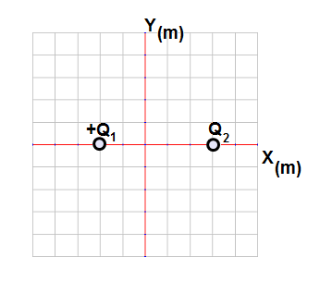
  - Its strength increases radially outward from the center.

- A point charge, Q₁ = +8.0 μC is placed at point x = -2 m and a second charge, Q₂ is placed at point x = +3 m, as shown to the right. The net electric field at the origin is zero. What is the magnitude and sign of Q₂?
Magnitude: Sign:
  - 12 μC Positive
  - 12 μC Negative
  - 18 μC Positive
  - 18 μC Negative

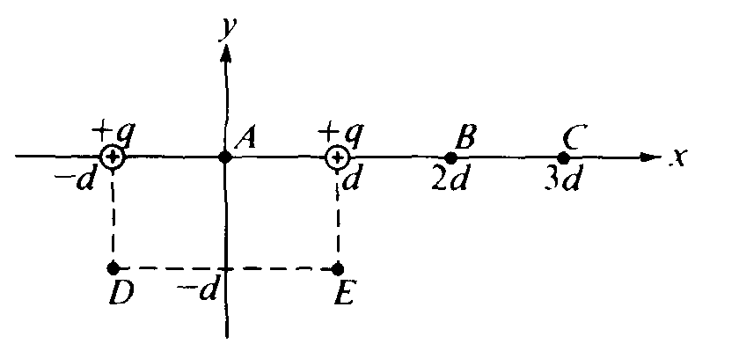
- Two positive charges of magnitude, q, are each a distance d from the origin A of a coordinate system as shown to the right. At which of the following points is the electric field least in magnitude?
  - A
  - B
  - D
  - E

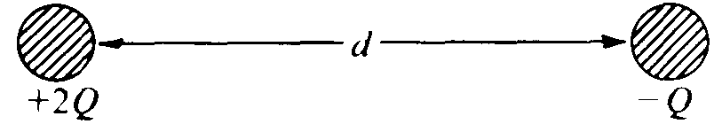

- Two identical conducting spheres are charged to +2Q and –Q, respectively, and are separated by a distance d (much greater than the radii of the spheres) as shown above. The magnitude of the force of attraction on the left sphere is F₁. After the two spheres are made to touch and are then separated by the same distance d, the magnitude of the force on the left sphere is F₂. Which of the following is correct?
  - F₁ = 2F₂
  - F₁ = 8F₂
  - F₁ = 1/2 F₂
  - F₁ = 1/8 F₂

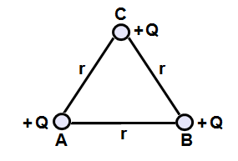
Questions 5-6

Three charges, +Q, are located at the vertices of an equilateral triangle of sides r.

- What is the direction of the net force on charge C due to charges A and B?
A. B.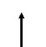 C. D.

- What is the magnitude of the net force on charge C due to charges A and B?
  - $k\frac{Q^{2}}{r^{2}}$
  - $\sqrt{2}k\frac{Q^{2}}{r^{2}}$
  - $\frac{\sqrt{2}k}{2}\frac{Q^{2}}{r^{2}}$
  - $\sqrt{3}k\frac{Q^{2}}{r^{2}}$

- A hollow metal sphere of radius R is positively charged. Of the following distances from the center of the sphere, which location will have the greatest electric field strength?
  - 0 (center of the sphere)
  - 5R/4
  - 3R/2
  - 2R

- Two isolated charges, +q and -2q are 2 cm apart. If F is the magnitude of the force acting on charge -2q, what is the magnitude and direction of the force acting on +q?
Magnitude Direction
  - F/2 Towards charge -2q
  - F/2 Away from charge -2q
  - F Towards charge -2q
  - F Away from charge -2q

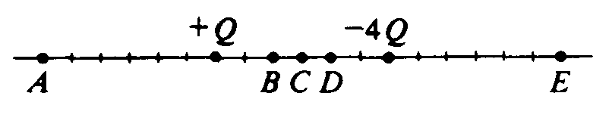
- Charges +Q and -4Q are situated as shown above. The net electric field is zero at which point?
  - A
  - B
  - D
  - E
- An isolated conducting sphere of radius R has positive charge Q. Which graph depicts the electric field as a function of r, the distance from the center of the sphere?

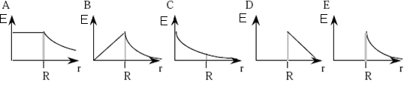

Questions 11-12
A proton with a charge q and mass m_{p} is accelerated from rest for time τ by a uniform electric field, E.

- What is the magnitude of the electric force exerted on the proton?
  - E/q
  - q/E
  - qE/τ
  - qE

- The velocity of the proton after it has accelerated for time τ is:
  - qEτ/m_{p}
  - qτ/m_{p}
  - Eτ/m_{p}
  - Fτ/qm_{p}

- Which of the following are possible interactions between two charges? Select two answers:
  - B.

  - D.

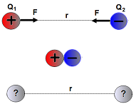
- As shown to the right, a charged sphere, Q₁ = +9Q, is separated from a second charged sphere, Q₂ = -3Q, by a distance, r. They briefly touch and move back to the original distance, r. Which of the following is true about the new charge on and the force between the spheres? Select two answers:
  - The new charge on each sphere is +6Q.
  - The new charge on each sphere is +3Q.
  - The new force is repulsive.
  - The new force is attractive.

Multiple Choice 1 point each, 14 points total
- C 3. A 5. B 7. B 9. A 11. D 13. C, D
- C 4. B 6. D 8. C 10. E 12. A 14. B, C

